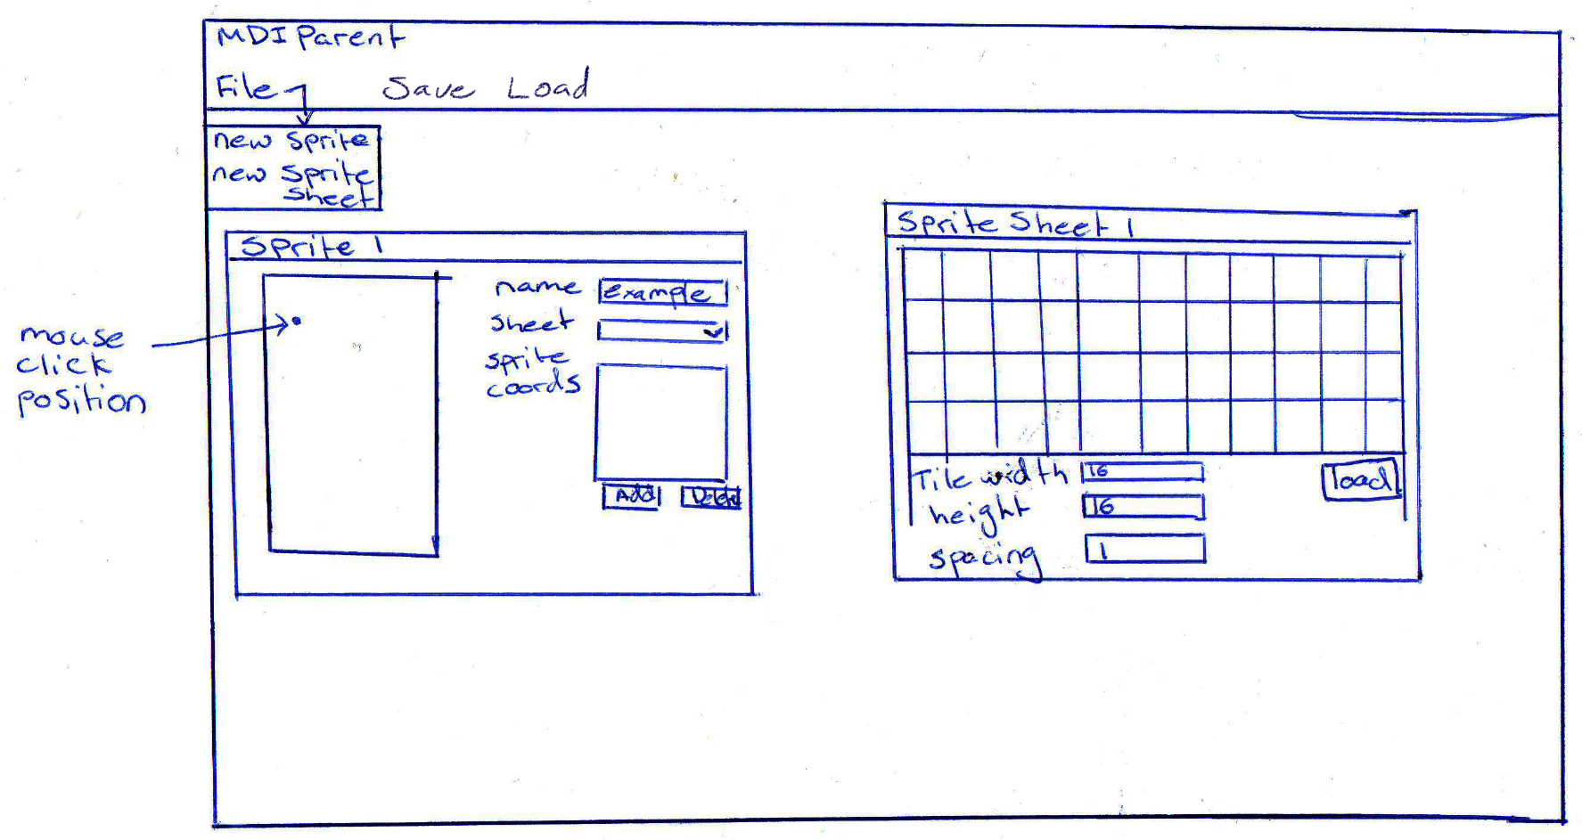

# Intended Use:

* Allows you to load in a sprite sheet and specify the tile size
* Using the sprite sheet will allow you to select a tile and then click to place it at this point on the sprite window, allowing you to build a scene
* Can select a sprite from the list box labelled “Sprite Coords” and then delete it from both this list and the picture box it is drawn to by hitting the delete button
* Clicking save will let you save the sprite as either a .xml or .png file
* Clicking load will let you load in either a .xml or .png image into the sprite picture box to edit

# Nondeterministic Finite Automata:

